CS301 Data Structure Final Term Subjective (05-02-12)
Total Marks=80
Total questions=52
MCQS=40
Short questions=12
Q1.which proces places data at the back of the queue? 2
Q2.Give the name of two sorting algorithem that dont follow "divid ad conquer" strategy? 2
Q3.How a heap sort work to sort a set of data? 2
Q4.If data is in sorted order what will be its impact on find operation of table ADT? 2
Q5. Apply operation delMin on it and show the resultant heap? 3
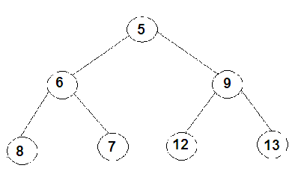
Q.6 how many parameters are required for performing the following operations on table also tell name of these parameters.
1. Insert
2. Find
3. Remove
Q.7 how is an array of ten integer. 3
5,3,8,9,1,7,0,2,6,4
draw this array after the first iteration of main loop of insertion sort (sorting from smallest to largest).this iteration has shifted at least one item in array.
Q.8 Here is a small binary tree 5
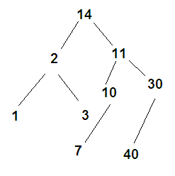
write the order of nodes visited in
A.an in order traversal
B.a pre order traversal
Q.9 Show the steps of merge sort procedure applied to the following list 5
22,31,42,11,12,41,23,13,21,33
Q.10 consider the following heap 5
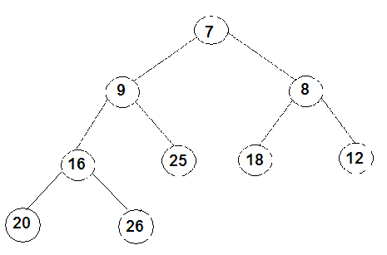
1.is it min heap or max
2.show the context of array used to store it in array

